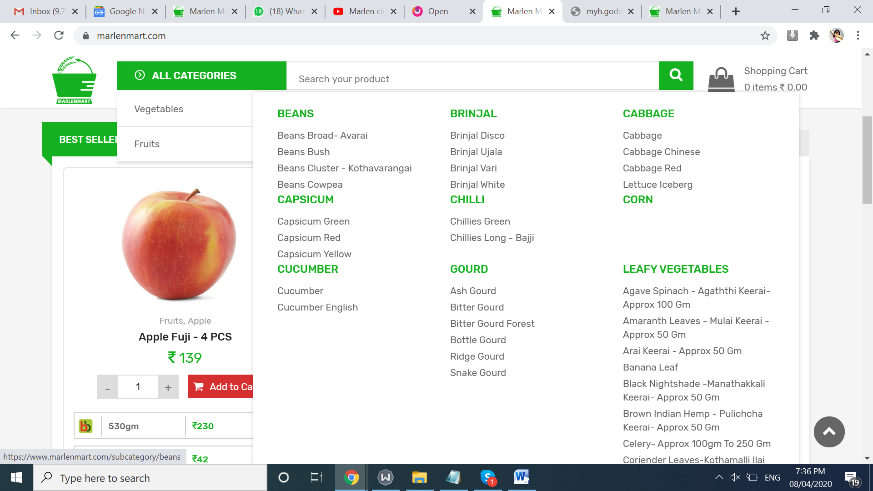

Tas k 1 - the values of leasfy vegetables are not visible – we need a scroll down in this

TASK 2:

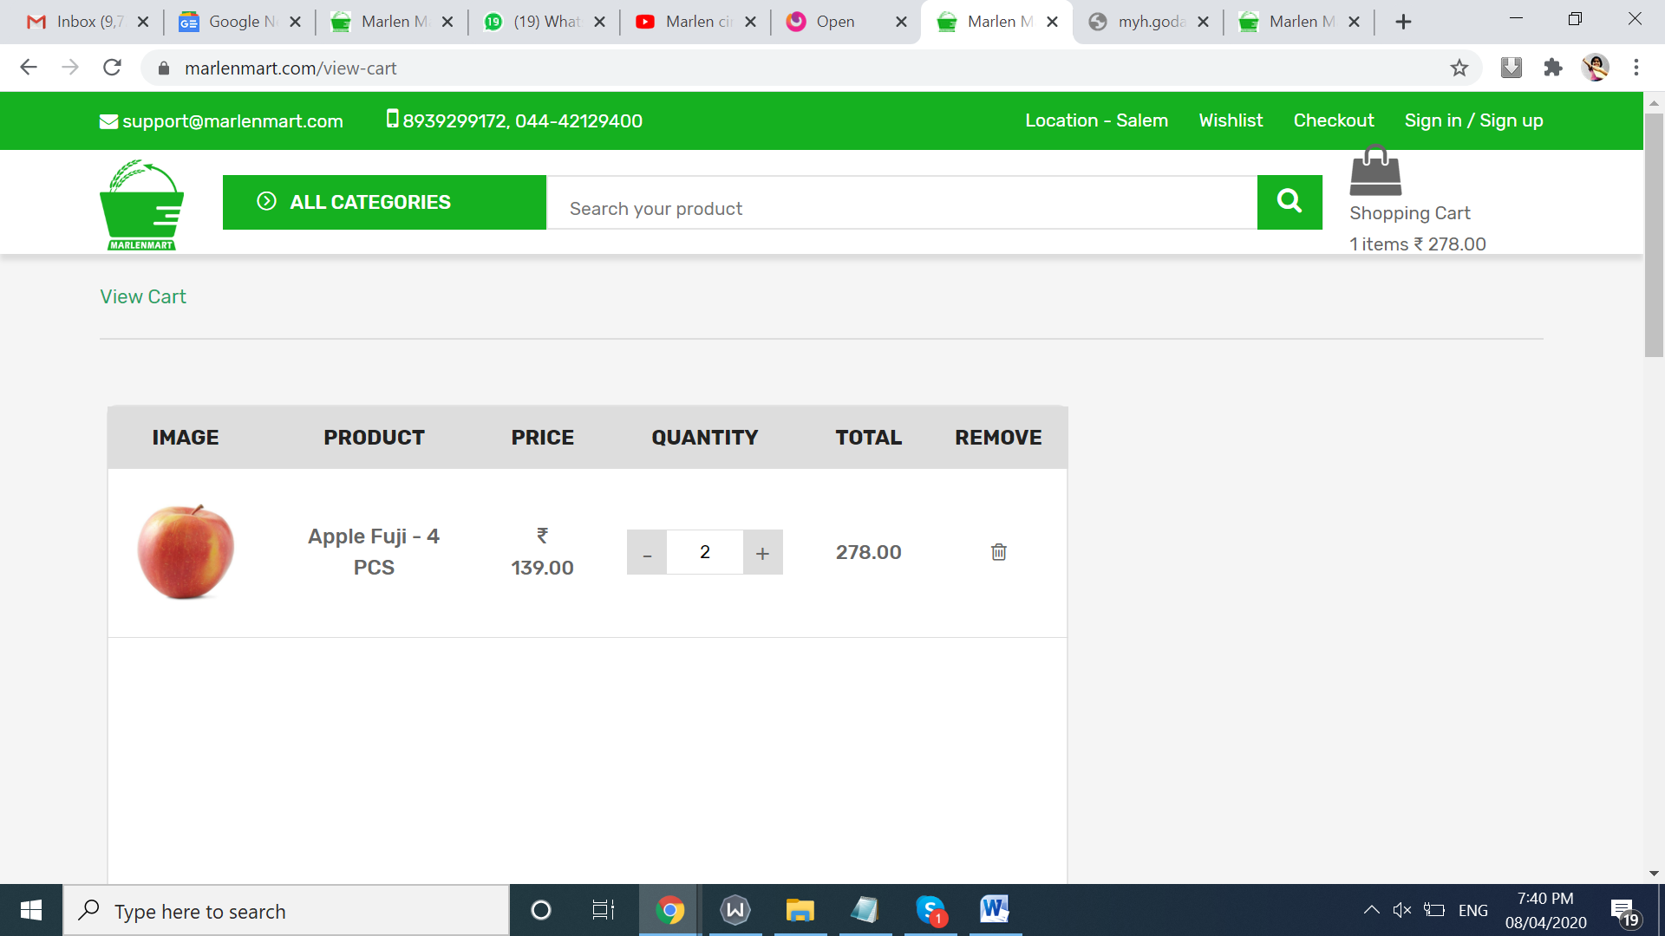

IN cart page – if you increase or reduce the quantity it should change the total value – ie without using the update cart button things should happen.

Task 3:

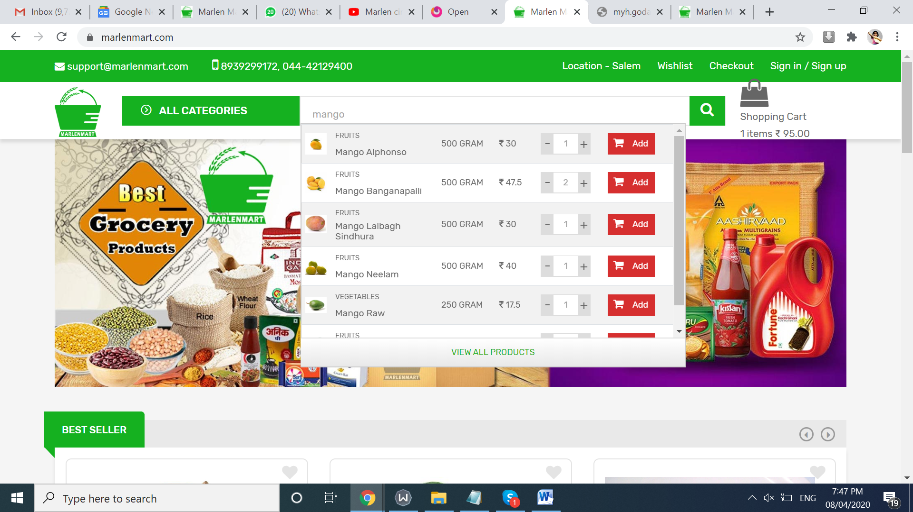

When I come out of the search box this dropdown result is not going. This dropdown goes only when we delete the search word mango. Kindly make sure – this result goes when we take the cursor out of the search box.

TASK 4;

‘

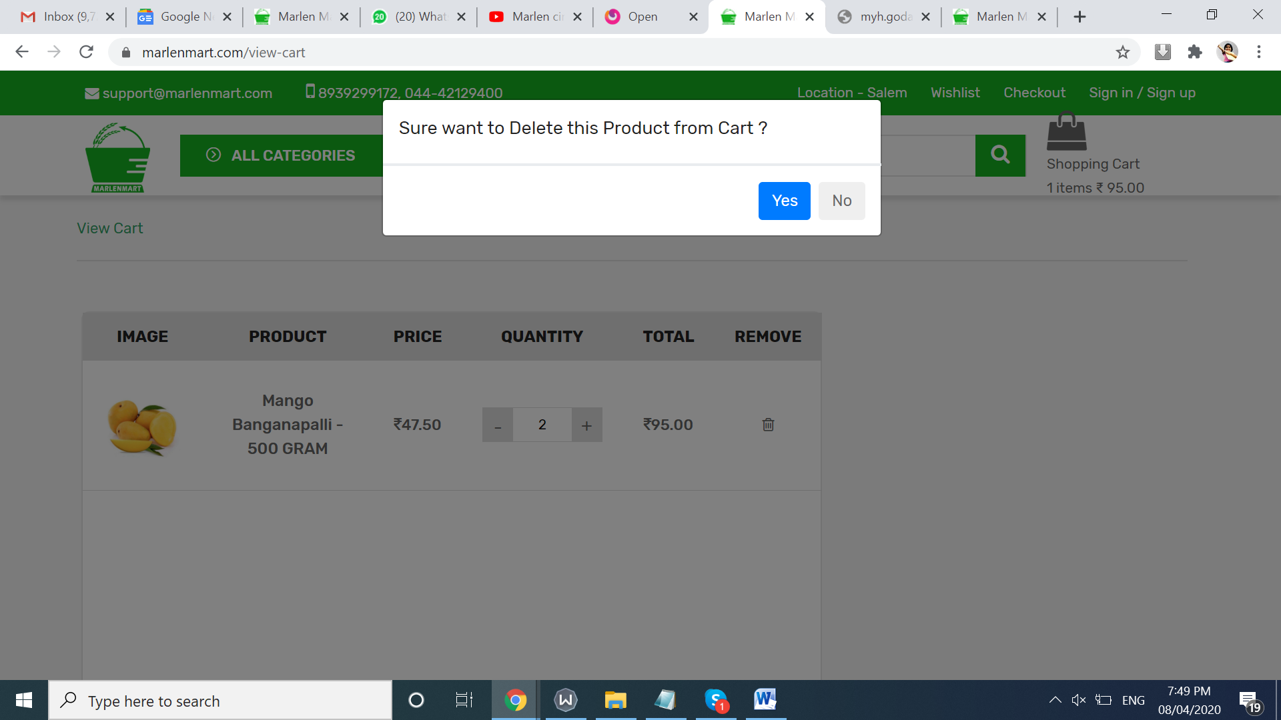

We no need to show this alert msg if he click the Close mark or \* mark in the view cart.